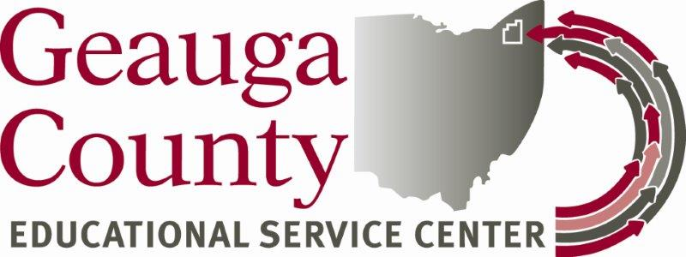

Geauga County Educational Service Center (GCESC)
Business Advisory Council (BAC)
Bylaws

Participating School Districts in Geauga County: Berkshire Local School District, Cardinal Local School District, Newbury Local School District, West Geauga Local School District, Geauga iStem Early College High School and the Geauga County Educational Service Center

Mission Statement (Per ORC 3313.84): The mission of the GCESC Business Advisory Council (BAC) is to foster cooperation among our member schools, businesses, and the communities they serve to make our education system more aware of the local labor market; promote work-based experiences within businesses; and help students prepare for successful learning and employment opportunities.

Roles of the BAC (Per ORC 3313.84):
- To advise local school districts on changes in the economy and job market and the area in which future jobs are most likely available;
- To advocate for the employment skills most critical to business and industry and the development of curriculum to teach these skills;
- To aid and support local school districts by offering suggestions for developing a working relationship among businesses, labor organizations, and educators;
- To advise workforce development on how to be responsive to Northeast Ohio job market.

Member Appointments:
- County Superintendent (permanent member) serves as Executive Chair
- 5 Superintendents and representatives from GCESC Member Districts (permanent members)
- 1 Representative from Geauga Growth Partnership (permanent member)
- 1 Representative from Auburn Career Center (permanent member)
- 1 Representative from Higher Education – Kent State (permanent member)
- At least 8 members from local or regional businesses and industries that represent diversity in the business communities. (staggered terms)
- Additional At-large Members may be added at the discretion of the BAC in
multiples of 2 (3 year terms)
- Representative from workforce development. At the discretion of the BAC for 3 year term.
- Voting authority – two members from same entity – 1 vote.

Terms of Service:
2 Businesses – 1 year
3 Businesses – 2 year
3 Businesses – 3 year
Thereafter all 3 years

The BAC shall avoid potential conflicts of interest when appointing BAC members. The GCESC Superintendent has the right to remove BAC members due to potential conflicts of interest, lack of attendance/participation, lack of cooperative spirit, or any other reason as determined by GCESC in partnership with GGP.

Appointment & Responsibility of Officers: Officers for the following offices: Chairperson, Vice-Chairperson, and Secretary shall be appointed by the GCESC Superintendent at the annual BAC Business Meeting in July or August each year. Officers shall be appointed from active Board members and will be appointed for 1 year terms. The responsibilities of each office are as follows:

- Chairperson – Superintendent of County
  - Provide leadership to ensure the committee functions properly
  - Promote full participation during the meetings
  - Ensure that all relevant matters are discussed and that effective decisions are made and implemented
  - Lead and Facilitate each meeting

- Vice Chairperson:
  - Assume the responsibilities of the Chairperson in his/her absence

- Secretary: Assumed by ESC Representative

Meeting Schedule: The GCESC BAC meeting schedule will be determined annually at the Business Meeting to be held in July or August of each year. (The BAC will meet at least once per quarter as required by Ohio law.)

Sunshine Laws: The GCESC BAC will comply with Ohio’s public records and open meetings laws, collectively known as the “Sunshine Laws” as required by law.

Amendment of Bylaws: Bylaws of the GCESC BAC may be amended at any official BAC meeting by a majority vote of BAC members present at the meeting.

